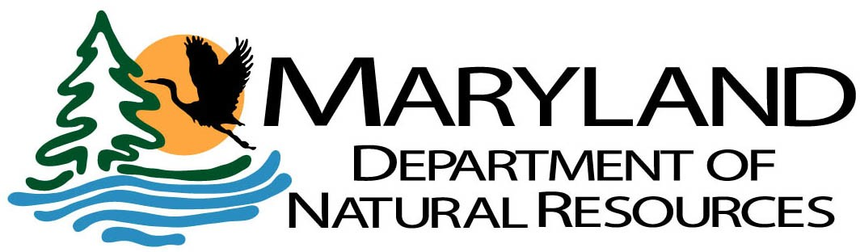

CHESAPEAKE AND COASTAL SERVICE (CCS)
CENTER FOR WATERWAY IMPROVEMENT & INFRASTRUCTURE APPLICATION FOR WATERWAY IMPROVEMENT FUND (WIF) GRANT

SERVICE CONTRACT (SC) GRANT
GRANT PERFORMANCE PERIOD July 1, 20 – June 30, 20 .*

5K GRANT
GRANT PERFORMANCE PERIOD – . (Not to exceed 1 year)**

APPLICANT INFORMATION

Applicant Name:

Applicant Address:

Federal Tax Identification Number:

Review the Waterway Improvement Fund Grants Manual for more information

APPLICATION TYPE

Service Contract (Maximum of $15,000) 5K
[ ]
[ ]

PROJECT INFORMATION

Project Name: Project Address (Street/City/Zip): County:

CONTACT INFORMATION

Local Project Coordinator: Title: Coordinator Address: Phone: Ext: Email:

Page 1 of 3 Updated May 2022
Tawes State Office Building – 580 Taylor Avenue – Annapolis, Maryland 21401
410-260-8DNR or toll free in Maryland 877-620-8DNR – dnr.maryland.gov – TTY Users Call via the Maryland Relay

PROJECT DESCRIPTION, SCHEDULE AND CURRENT STATUS

  - Service Contract Grants:

    - Number of boating facilities serviced: . Name(s) of facility(ies):

    - Contract awarded: Yes No
(If yes, please provide bid tab/quotes and a copy of the executed contract)

  - 5K Grants:

    - Provide a detailed project description (Attach any available site plans/drawings/photographs of proposed project):

    - Provide the project schedule below:

Phase | Start (Month/Year) | Completion (Month/Year) | Percent Completion
Planning
Design
Bidding
Construction

    - Have all necessary permits been obtained? Yes No N/A
If no, provide status:

PROJECT FUNDING

  - Identify the Project Funding Sources for your project in the tables below:
[ ]
[ ]

WIF Funding Request | Amount
TOTAL AMOUNT REQUESTED | x.

Other Funding | Amount
 |  | Funds Secured?
Applicant |  |  |  | Yes |  | No
U.S. Army Corp of Engineers |  |  |  | Yes |  | No
Federal USFWS |  |  |  | Yes |  | No
Other: |  |  |  | Yes |  | No
Other Funding Total | y. | Total of all Prior and Additional Funding Sources

Source Total (x. + y.) | $ | Total should match the Budget Total in II.b.

  - Identify the cost-breakout of the budget (Total Project Cost) in the table below:
[ ]
[ ]
[ ]
[ ]
[ ]
[ ]
[ ]
[ ]
[ ]
[ ]
[ ]
[ ]
[ ]
[ ]
[ ]
[ ]
[ ]
[ ]
[ ]
[ ]
[ ]
[ ]

Project Funding Use(s) | Amount | Are WIF Grant Funds Requested? |  |  |  |  | Is this line item already funded by an “Other Funding” source?
Service Contract |  |  |  | Yes |  | No |  |  | Yes |  | No
A/E Design |  |  |  | Yes |  | No |  |  | Yes |  | No
A/E Construction Management |  |  |  | Yes |  | No |  |  | Yes |  | No
Construction |  |  |  | Yes |  | No |  |  | Yes |  | No
Other: |  |  |  | Yes |  | No |  |  | Yes |  | No
Total Project Cost | $ | Total should match the  Source Total in II.a.

Page 2 of 3 Updated May 2022
[ ]
[ ]
[ ]
[ ]

* Service contract grants provided for sanitary services at publicly owned boating facilities are limited to a maximum of nine (9) months per boating season (March 1st – November 30th). Reimbursements will be made on a FY basis (Jul-Nov, Mar-Jun). This does not affect DNR sponsored projects such as marine sewage pumpout stations. Grant balances not disbursed 2 months after the end of the FY are subject to immediate reversion by DNR.

** The Department may expend a total of $125,000 each fiscal year, for a total of (25) grants not exceeding $5,000 each. Projects including, but not limited to, minor construction, repair and navigation at public boating facilities will be considered for 5k grant(s) and should be ready to proceed to construction. Grant balances not disbursed after one year are subject to immediate reversion unless an extension is granted by the administration.

This document may be executed in multiple counterparts, each of which shall be deemed an original, and all of which together shall constitute one and the same instrument. Signatures, including notary signatures, provided by electronic means including, by way of example and not of limitation, facsimile, Adobe, PDF, and sent by electronic mail, or via an electronic signature program, shall be deemed to be original signatures.

I CERTIFY THAT I AM AN AUTHORIZED OFFICIAL PERMITTED TO SIGN AND SUBMIT THIS APPLICATION ON BEHALF OF THE APPLICANT. I FURTHER CERTIFY THAT ALL INFORMATION IN THIS APPLICATION AND THE ATTACHED MATERIALS ARE TRUE AND CORRECT.

Name: Title: Authorized Official Signature: Date:

GENERAL INFORMATION FOR APPLICANTS

- All necessary federal, state and local permits and approvals must be secured prior to start of construction.

- All plans, specifications and proposed changes must be submitted for review and approval by the Program.

- The Applicant will prepare a tabulation of bids (if applicable) and/or other method of procurement and submit same to the DNR with comments and recommendations prior to the award of any contract.

- Projects that involve the construction, demolition, installation, alteration, repair, or salvage activities located in, on, over, or under State or private tidal wetlands must be performed by a licensed Marine Contractor. Information can be found at Maryland Dept of Environment (Licensed Marine Contractors).

- The Applicant agrees to operate and maintain the proposed project. Future maintenance funds are not guaranteed by the DNR.

APPLICATION SUBMISSION

Submit one (1) signed original of the complete application, attachments and all supporting documents to:

Ms. Carla Fleming, Director
Center for Waterway Improvement & Infrastructure Chesapeake & Coastal Service
Maryland Department of Natural Resources Tawes State Office Building
580 Taylor Ave., E-2 Annapolis, MD 21401

Page 3 of 3 Updated May 2022

