If you are experiencing difficulty logging into your compass account, please review the information below.

Can’t remember your password – On the homepage Click “Forgot Password?”
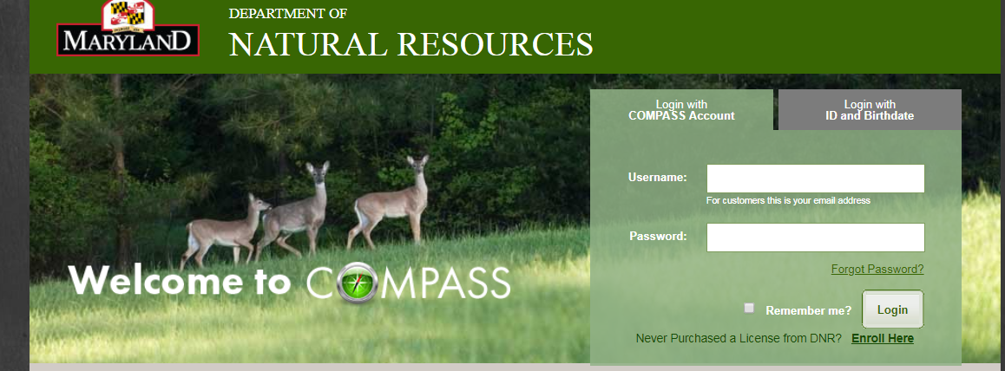

You will then be prompted to enter your email address
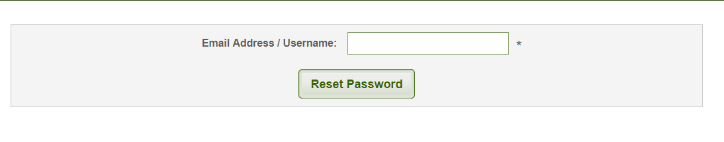
After entering your password, click reset password. You should see the message below with your email address listed.
An email has been sent to your email address. Please click on the change password Link to setup a new password.
If you do not receive the confirmation message within a few minutes, please check your Junk E-mail / Spam folder. If this message was in fact flagged as spam please be certain to mark as "Not Spam" so that future messages from COMPASS will get through.

Go to your email, you should have received an email from customerservice.dnr@maryland.gov. It will contain the message below.
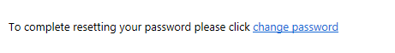

Once you click “change password”, the compass portal will appear with the screen below. Enter your User Name, then create and confirm a new password based on the password requirements below. Then click “create password”.
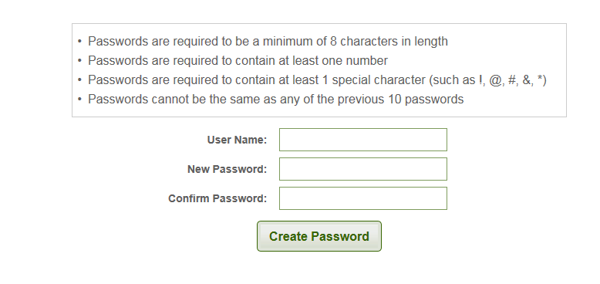
Once you click create password you see the compass portal log in screen. Enter your username and newly created password. Then click login to begin your license purchase.
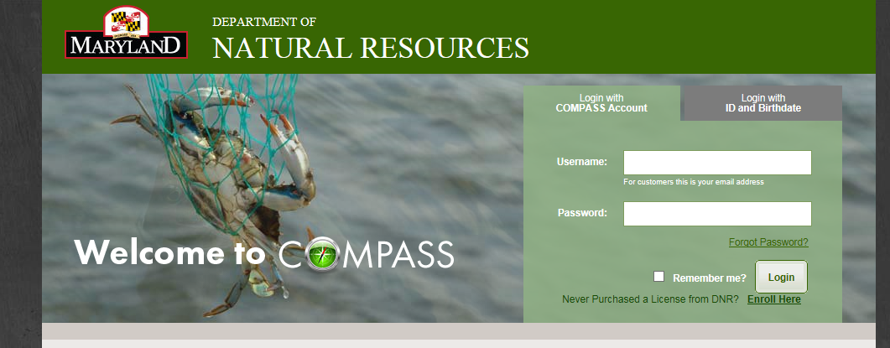
If you are still experiencing an issue after attempting to log in with your newly created password and username, you can log in using your DNRid and date of birth. If you don’t remember your DNRid, you can log in with your driver’s license number and date of birth.
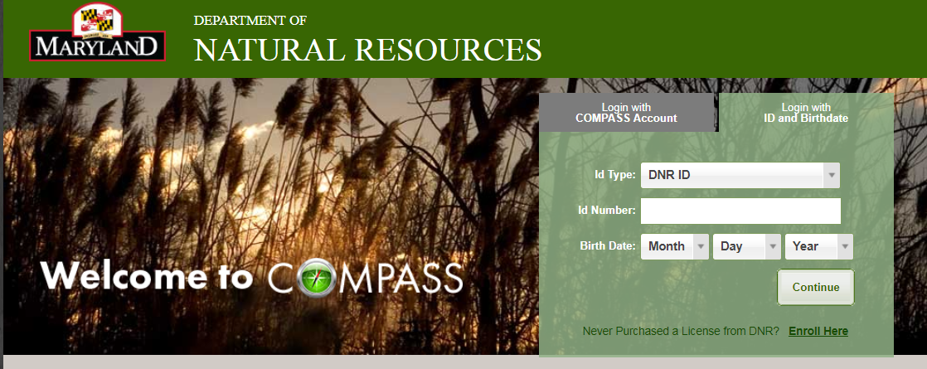

Once logged in you may still see the screen below. You can simply bypass the change password message by clicking the “home” icon in the top left corner of the page. This will take you to your homepage where you can begin to make your purchases.

Click here to get to your home page
